Client to complete:
Date | First Name | Family Name | Phone | Email
Lowest Handicap | Current Handicap | Handicap Goal | Best Score | Occupation
Other Sports Played |  |  | Any Ailments
Your Golf Goals |  |  | Ever Had Lessons (if yes how many, where and with whom?)
Competency Self-Assessment
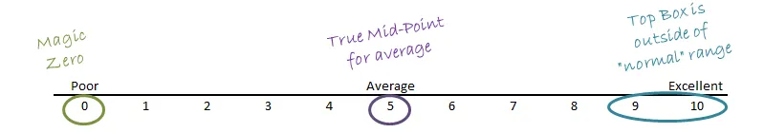

Aspect | Rating out of 10 | Description
Putting
Chipping
Pitching 10–60m
Bunkers
Irons
Hybrids / Fairway woods
Driver
Mindset
Fitness
Course Mgt.
Frustration
What do you want from this lesson
Coach or Instructor to complete:
Preparation |  |  | Pivot Motion
Aspect | Rating out of 10 |  | Aspect | Rating out of 10
Feet |  |  | Hip Rotation
Knees |  |  | Shoulder Rotation
Hips |  |  | Weight Shift Back
Shoulders |  |  | Weight Shift Down
Forearms |  |  | Finish Position
Eyes (focal points) |  |  | Club Position
Clubface |  |  | Hip-high Back
Grip |  |  | Shoulder High Back
Posture |  |  | Top of Swing
Ball Position |  |  | Start Down
Hand Position |  |  | Delivery Position
 |  |  | Impact Position
 |  |  | Hip-High Through
 |  |  | Finish
Coach / Instructor Feedback (about skills, technique, mindset and approach)
Suggested Drills |  | Recommended Lessons, Clinics or On-course Tuition

